5/600, Bazar Road, Mattancherri, Kochi, Kerala 682002, India. +91 94471 08011

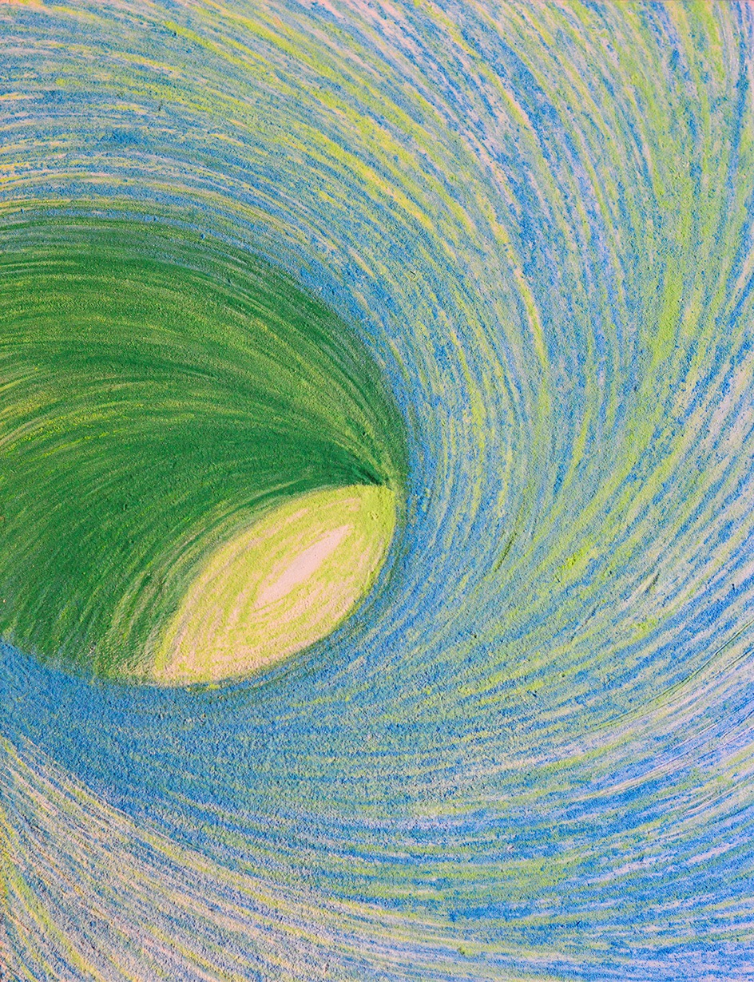
FOR IMMEDIATE PRESS RELEASE
TOGETHER ALONE
Feb 13 – Feb 26, 2016
Opening Reception: Saturday, Feb 13 from 5pm

Together Alone, an exhibition of works by Jayanthi Moorthy will be on view in OED Gallery from Feb 13 – Feb 26, 2016. The opening reception will be held on Saturday, Feb 13
from 5pm.

Together Alone relates to the various states of mind that arises as the pendulum marking our life’s journey swings between the extremes of solitude and companionship. A desire for togetherness can transform blissful solitude into painful loneliness driving us to seek company, whereas, even joyful companionship that stifles our individuality and freedom, induces a desire to be alone.
Together Alone, is Moorthy’s first one-person exhibition in India. The exhibition has works on canvas, a digital site-specific installation, and photographic prints. The works dating from 2013-2015 aims to create an environment for self exploration. Ten unstretched pieces of canvas, ranging from 6 feet to 12 feet, represents Moorthy’s meditations on these states of mind. They all seem as if woven with thick, bright colored threads – Moorthy’s signature way of painting with acrylics, squeezing blobs of paint into linear forms. These works are accompanied by a digital installation created on the floor with ephemeral materials like charcoal and rice flour, her personal way of drawing. The work entitled Fear, is a participatory piece, that envelops visitors and encourages them to contribute to the projected animation by responding to the question, ‘What is your worst fear?’.
Jayanthi Moorthy’s practice is inter-disciplinary, encompassing painting, photography and installation. Her works invite dialogues between cultures, and an inner dialogue with the self. She draws inspiration from India’s age-old cultural practices. Moorthy migrated from India in 2004 and now lives and works in New York. Born in Kolkata, India, she has studied art and design at Arts Students League, Parsons School of Design, MoMA and NYU. Moorthy’s works have been widely exhibited in New York and in the US. Her solo exhibitions include the DUMBO Arts Festival, NY (2014); A.I.R Gallery, NY (2014); Jacques Marchais Museum of Tibetan Art, NY (2012) and Sarah Doyle Gallery in Brown University, NY (upcoming in 2016). She was an artist-in-residence at Sanskriti Pratishtan, India (2010). For more information visit www.jaymoorthy.com
OED Gallery is located on 15/600, Bazar Road, Mattancherri, in the Fort Kochi neighborhood of Cochin, Kerala, India. Gallery hours: Monday, Wednesday - Sunday, 11-7pm. For additional information, please contact Jay at at
+91 484 2206248 or jm@jaymoorthy.com.

Image: Whirling (detail), 2015, 17 x 22 inches. Pigment print of artwork on floor with colored sand

