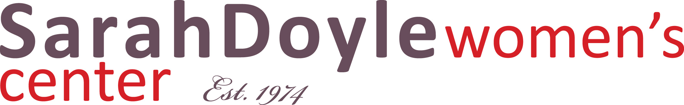
Sarah Doyle Gallery, Brown University, 26 Benevolent St., Providence, RI 02912, USA

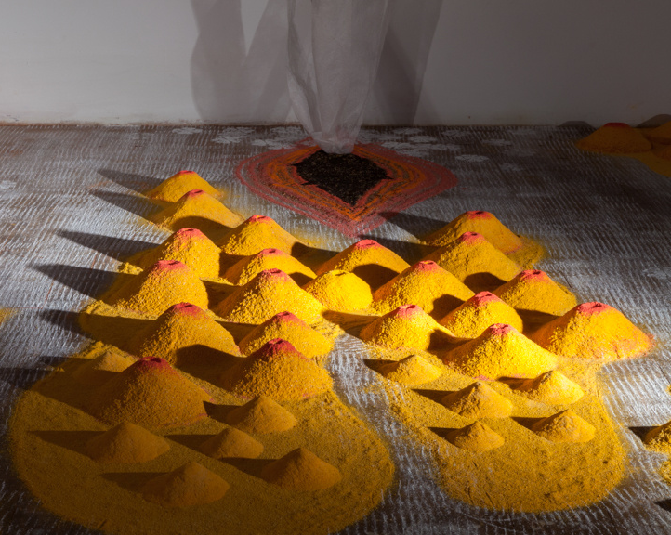

FOR IMMEDIATE PRESS RELEASE
DESIRE: UNCHECKED
Oct 2 – Oct 28, 2016
Opening Reception & Artist Talk:
Sunday, Oct 2, 3-5 PM

Desire: Unchecked, an exhibition of works by
Jayanthi Moorthy will be on view in Sarah Doyle Gallery from Oct 2 – Oct 28, 2016. The opening
reception will be held on Sunday, Oct 2, 3-5 PM.

Desire: Unchecked examines our mind as it easily slips into various states of desire namely: desire for love and lust, desire for freedom and power, desire for connectedness and balance. Desire has the capacity to both enslave and liberate us — the “I want more!” saga, never ends. And in it’s absence it develops within us a detachment towards everything material and non-material. We then start looking inwards for strength and direction which in turn gives rise to faith.

Desire: Unchecked, is Moorthy’s fourth one-person exhibition that has site-specific installation, video, paintings and prints. The collection of works dating from 2014-2016 aims to create an environment for self exploration. The 7 feet painting In & Out, which expresses the desire for freedom, looks as if woven with bright colored threads on canvas cloth — Moorthy’s signature style of painting with acrylics by squeezing paint into linear forms. The prints which are photographs of her drawings with ephemeral materials, captures various states of desire including the desire to eat! The installation Aroused expresses lust and the video work Consistent Desire, reminds us of our un-abating desires.
Jayanthi Moorthy makes paintings, prints, installations and video. Her works explore various aspects of personal and cultural identity and their contemporary interpretations. She derives inspiration from cultural practices of the East and West, ritual practices and philosophies from Hinduism and Buddhism and, the ever-changing nature. Moorthy immigrated from India in 2004 and now lives and works in New York. She was born in Kolkata, India. She is an artist, cultural producer and educator. Moorthy is predominantly a self-taught artist and has studied professional courses at The Arts Students League and MoMA. Moorthy’s works have been exhibited in US and India. Her solo exhibitions include, OED Gallery (India), DUMBO Arts Festival (New York); A.I.R Gallery, (New York); Jacques Marchais Museum of Tibetan Art, (New York). She was awarded a fellowship by A.I.R Gallery (New York) and is currently part of the Immigrant Artist Program run by New York Foundation for Arts (New York). For more information visit
www.jaymoorthy.com
Sarah Doyle Gallery is part of Brown University’s Sarah Doyle Women’s Center. It is located in 26 Benevolent Street, Providence, RI. Gallery hours: Monday - Friday, 9-5 PM. For additional information, please contact 401-863-2189 or sarahdoyle-galley@brown.edu

Image: Aroused (detail), 2015, site-specific installation. Rice flour, turmeric, charcoal, colored sand and cloth

